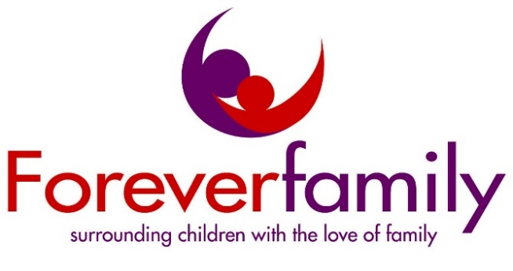

**Gift and Uplift 2019**

***Inspire hope in a Child this Christmas***

*Foreverfamily, Inc. is announcing its annual Gift& Uplift and we need your help by donating gifts for 100 children and teens in our program*

Imagine—you are a parent and unable to give your child a gift for Christmas. Imagine—you are the child of an incarcerated parent—all you want Christmas morning is your mother’s embrace. The holiday season can be a difficult time of year for children who are separated from their incarcerated parent. Each year, Foreverfamily seeks to lessen stress by providing the children with the opportunity to celebrate the holiday season with a gift. Please support Foreverfamily’s effort by donating unwrapped toys, games, or gift cards. Foreverfamily mothers will have the opportunity to select a gift for their child. We can also use Christmas wrapping paper and bows to help mother’s wrap the gifts.

Celebrating Christmas with your mother, when she is incarcerated, truly is a Christmas miracle. Your donation is so much more than a gift—it’s a memory for a mother and her child. Foreverfamily thanks you for your support and wishes joy and blessings to you and your family this holiday season.

*Foreverfamily, Inc is a nonprofit organization that provides support services to children affected by a parent’s incarceration. Our mission is: To inspire hope in children of incarcerated mothers and fathers, to help the children become successful adults, to strengthen their families, and to encourage communities worldwide to do the same. We provide our children with enrichment programs and opportunities to see their parents. Every month, we provide transportation to three GA women’s correctional facilities for family visits so that the family can maintain crucial bonds. We also organize a Youth Summit and provide college and career readiness along with youth service.*

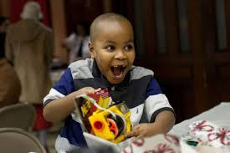

Please contact [volunteer@foreverfam.org](mailto:volunteer@foreverfam.org) to schedule delivery of unwrapped gifts by **DEC 9th**



